**For Mathematics Teacher**

**Teacher:** Kokming Lee

**Course:** Pre-IBDP Mathematics (2018-2019, Statistics and probability, Math proof and number theory)

**Email:** [kmlee@uwcchina.org](mailto:kmlee@uwcchina.org)

**School:** United World College Changshu China

**Mathematical Awards/Honors:**

* will take AMC 12 in February, 2019;
* 2018, First Prize (China), Math League, qualified for US Final (at Stanford) and its Math Camp (co-held by the Departments of Mathematics of Princeton University, Columbia University and Williams College);
* 2017, Second Price, Jiangsu Junior High School Mathematics Competition;
* 2017, Second Place (Global Final), The Berkeley Mini Math Tournament (BmMT);

**Involvement in Mathematics (Activities or Projects):**

Ruiyan is currently doing a passion project on Mathematics in Air Pollution. She applies what she has learned last term in our math course in this project. She is recording all relevant data of air pollution in this region for a year and doing a project on analyzing and modelling the variation of different pollutants, along with the effect of time and season on the spread of these pollutants. After all the analysis and modelling, some possible solutions for the air management will be proposed for better air quality. In order to achieve the math model, she is self-studying extra math knowledges including matrix and linear regression, which are not covered in the course.

**Your Passion for Mathematics:**

Ruiyan’s passion for Mathematics derives from her willingness to take on new challenges and her sense of achievement gained after pushing her limits. She enjoys the feeling of being alone in the world of mathematics and dealing with numbers and curves without any disturb from the outside world.

**Your Understanding of Mathematics:**

For Ruiyan, Mathematics is a subject of interdisciplinary. It is the basis for her study of sciences; it helps with the investigation in her social studies, as she applies statistics and probability a lot in her data analysis of the experiments of social norm; it can also inspire her in art creation because of the symmetry, simplicity of math, as well as the use of projective geometry.

**Your Goal in Mathematics:**

The goal for Ruiyan in Mathematics is not only to develop a rigorous thinking habit for life, but also to use mathematics as a tool to help solve real-world problems, just like her project on mathematics in air pollution, as well as broader fields of application.

**Summer Programs**

**HCSSiM**

The link will be sent later

**Math Camp** (ddl: March 15)

The form has been sent to your email.

Here is the link for the instructions:

<http://www.mathcamp.org/2019/apply/teacher_instructions.pdf>

**PROMYS** (ddl: April 1)

Here is the link for the online form:

<https://promys.org/Teacher-Recommendation-Form>

**Mathworks (HSMC)**

Here is the link for the online form:

[**https://www.txstate.edu/mathworks/camps/applications/teacher-recommendation.html**](https://www.txstate.edu/mathworks/camps/applications/teacher-recommendation.html)

The program applying:

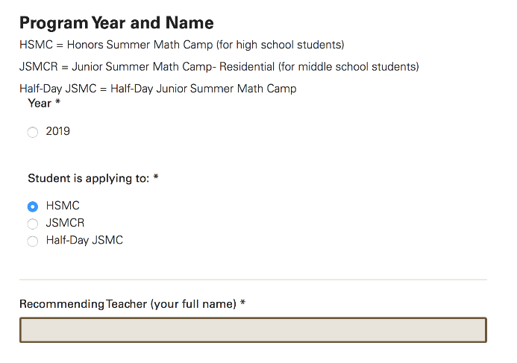

**MathILy**

The link will be sent later

**AwesomeMath**

The link will be sent later